**PROJECT TITLE: COMPREHENSIVE DIGITAL MARKETING FOR NOISE**

**STUDENT NAME: SHAIK ZOYA FATHIMA**

**PROJECT SUPERVISOR: Dr.Varoodhini**

**DEPARTMENT: BBA**

**COLLEGE: SATYA INSTITUTE OF TECHNOLOGY AND MANAGEMENT**

**TEAM ID: LTVIP2025TMID24590**



# INTRODUCTION

In today's fast-paced digital landscape, **comprehensive digital marketing** is essential for brands like *Noise*—a leading name in smart wearables and audio devices—to establish a strong online presence, engage customers, and drive sales.

A well-rounded digital marketing strategy integrates various channels, including **social media, content marketing, search engine optimization (SEO), pay-perclick (PPC) advertising, influencer collaborations, and email marketing**, to create a seamless brand experience.

Noise, in its broadest sense, refers to any unwanted or disruptive sound or interference that affects communication, perception, or understanding. It can manifest in various forms—acoustic noise in the environment, informational noise in media and communication, or psychological noise that distorts clarity in decision-making. In society, noise plays a complex role, sometimes serving as a distraction and other times as a tool for attention and influence. Whether in marketing, politics, or everyday life, the presence of noise can shape how messages are received, often forcing individuals or groups to filter through excess information to find meaningful content. Understanding noise and its impact is crucial in navigating modern environments where competition for attention is constant



In today’s digital age, a comprehensive digital marketing strategy is crucial for brands like *Noise* to establish a strong online presence and connect with their target audience effectively. As a leading brand in smart wearables and audio devices, *Noise* must leverage multiple digital channels, including social media, content marketing, SEO, PPC advertising, influencer collaborations, and email marketing, to maximize visibility and engagement. By integrating these strategies, the brand can enhance customer experience, build brand loyalty, and drive conversions. A well-executed digital marketing approach not only helps *Noise* reach potential customers but also strengthens its position as an industry leader in the competitive smart technology market.

## Brand Study of Digital Marketing Noise

In the digital marketing space, brands must develop a strategic approach to stand out amid the overwhelming "noise" of online advertisements, social media content, and promotional messages. A strong brand strategy focuses on differentiation, ensuring that a brand’s voice is distinct and recognizable. This begins with clear brand positioning, where companies define their unique value proposition and maintain consistency in their messaging, visuals, and tone across platforms. Targeted messaging is also essential, as modern consumers are bombarded with information; brands that use data-driven insights to personalize content can capture attention more effectively. Additionally, authenticity and storytelling play a crucial role in cutting through the noise— consumers are more likely to engage with brands that share genuine, relatable stories and align with their values. By combining these elements, brands can rise above the digital clutter, foster stronger customer relationships, and build long term loyalty.

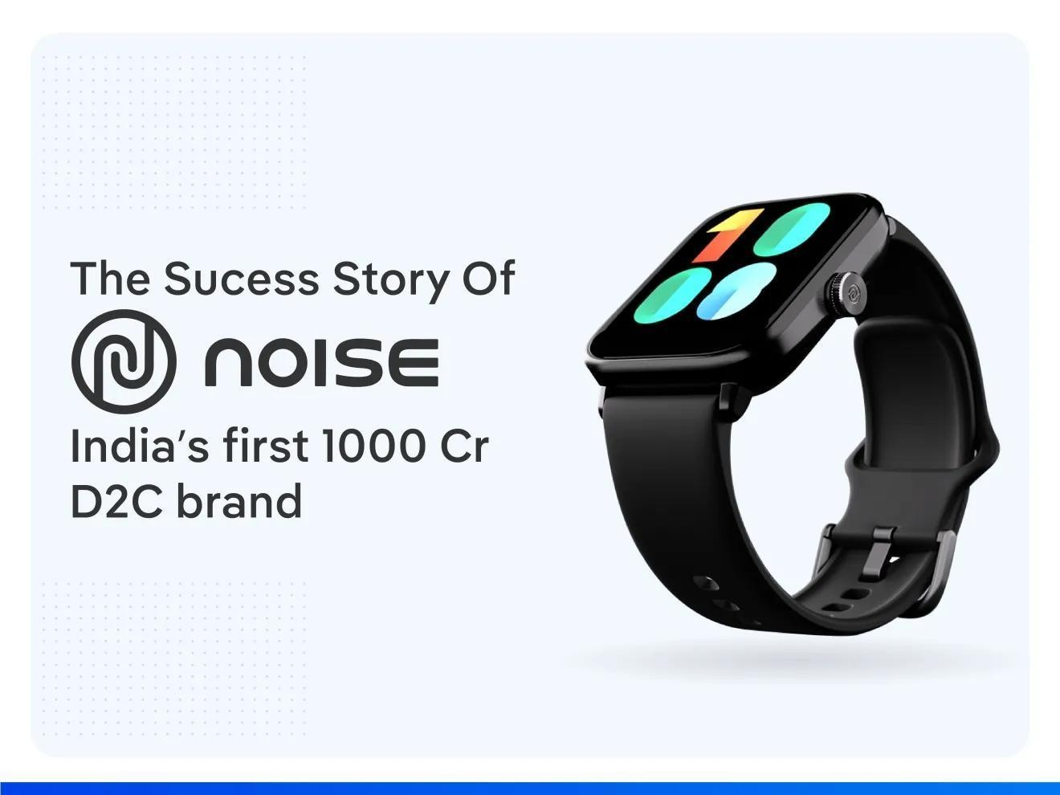

Noise, one of India’s leading smart wearable and audio brands, has leveraged digital marketing to establish itself as a household name in the industry. With a customer-first approach, the brand utilizes innovative social media strategies, influencer collaborations, SEO, performance marketing, and content marketing to drive engagement, increase brand visibility, and enhance customer experience. This study explores how Noise has effectively used digital marketing to build its brand and expand its market presence. A strong brand strategy focuses on differentiation, ensuring that a brand’s voice is distinct and recognizable. This begins with clear brand positioning, where companies define their unique value proposition and maintain consistency in their messaging, visuals, and tone across platforms. These users prioritize affordability, functionality, and modern aesthetics, making Noise an ideal choice for those who seek premium features at budget-friendly prices. A strong brand strategy focuses on differentiation, ensuring that a brand’s voice is distinct and recognizable.

## Competitor Analysis of Digital Marketing Noise



Noise operates in the highly competitive smart wearables and audio market in India, where brands leverage digital marketing, innovation, and aggressive pricing strategies to capture consumer attention. Key competitors of Noise include boat Fire-Boat ,Realme, and OnePlus, among others. This analysis compares Noise with its major competitors based on key factors like product offerings, pricing, digital marketing strategies, brand positioning, and market share. Competitor analysis of digital marketing noise involves examining how brands in a given industry are communicating online and identifying the volume, frequency, and effectiveness of their messaging. It includes assessing competitors' social media engagement, content strategies, paid advertising efforts, SEO performance, and audience interactions to determine how crowded the digital landscape is. By analyzing key players' strengths and weaknesses, businesses can identify opportunities to stand out, refine their messaging, and reduce unnecessary noise. Understanding which platforms competitors dominate, the type of content that resonates with their audience, and the gaps in their strategy allows for a more targeted, impactful approach to digital marketing. . It includes assessing competitors' social media engagement, content strategies, paid advertising efforts, SEO performance, and audience interactions to determine how crowded the digital landscape is. Key competitors of Noise include boat Fire-Boat ,Realme, and OnePlus, among others. This analysis compares Noise with its major competitors based on key factors like product offerings, pricing, digital marketing strategies, brand positioning, and market share.

## Research Brand Identity of Noise

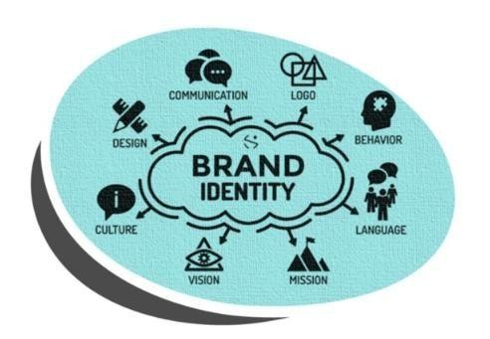

Noise is a leading Indian brand in the smart wearables and audio technology segment, known for its youthful, tech-savvy, and lifestyle-oriented branding. The company has successfully positioned itself as an affordable yet premium brand, offering feature-rich smartwatches, earbuds, and accessories.

The brand identity of "noise" in digital marketing represents the overwhelming flood of content, advertisements, and promotions that constantly compete for consumer attention in the digital space. In an era where audiences are bombarded with information from multiple channels—social media, email marketing, paid ads, influencer collaborations, and more—brands often feel the need to be louder, more frequent, and more disruptive to stand out. This identity is characterized by high-energy visuals, bold typography, fast-paced videos, attention-grabbing headlines, and trend-driven content that aims to stop users from scrolling. Brands that embrace noise often prioritize virality, using exaggerated messaging, humor, controversy, or shock value to generate immediate engagement. However, while being loud and highly visible can increase reach, it can also come at the cost of authenticity and audience trust. Too much noise can lead to consumer fatigue, making it difficult for brands to establish a meaningful connection with their audience. Additionally, as more brands adopt aggressive digital marketing tactics, the competition for attention becomes even more intense, requiring businesses to find a balance between being heard and maintaining a consistent, value-driven brand presence. Successful brands navigate this challenge by ensuring that their noise in this **Target Audience Persona of Noise**



Brands that embrace noise often prioritize virality, using exaggerated messaging, humour, controversy, or shock value to generate immediate engagement. However, while being loud and highly visible can increase reach, it can also come at the cost of authenticity and audience trust.

Noise has successfully built a strong audience persona by targeting tech-savvy, digitally connected, and lifestyle-driven consumers. The brand primarily appeals to young professionals, college students, fitness enthusiasts, music lovers, and digital nomads, offering smart wearables and audio accessories that fit seamlessly into their fast-paced lives. These users prioritize affordability, functionality, and modern aesthetics, making Noise an ideal choice for those who seek premium features at budget-friendly prices. Young professionals and students rely on smartwatches for notifications, fitness tracking, and style, while fitness enthusiasts look for durable wearables with health monitoring features. Music lovers prefer high-quality, wireless earbuds with long battery life and noise cancellation, making Noise a competitive alternative to global .

## SEO Of Noise



Noise has established itself as a leading smart wearable and audio brand in India. A strong Search Engine Optimization (SEO) strategy is crucial to enhancing its online visibility, driving organic traffic, and increasing conversions. By optimizing its website, content, and digital presence, Noise can rank higher on search engines, attract potential customers, and strengthen its brand authority in the competitive wearable market.

To optimize for the topic "noise" in digital marketing, it's essential to start with keyword research, identifying primary and secondary keywords such as "digital marketing noise," "online noise," and "marketing overwhelm." Next, on-page optimization techniques should be applied, including crafting a title tag, meta description, and header tags that incorporate these keywords. The content itself should also be optimized, using these keywords naturally throughout. Additionally, images should be optimized with descriptive alt tags and file names that include target keywords. From a technical standpoint, ensuring page speed, mobile-friendliness, and SSL encryption is crucial. Link building strategies, such as internal and external linking, guest blogging, and content marketing tactics like creating informative blog posts, infographics, and videos, can also help to establish authority on the topic and improve search engine rankings.

## Keyword Research on Noise

noise" means finding out what people search for online when they want

information about noise. This could be about noise pollution, ways to block noise, white noise for sleep, or noise-cancelling headphones. Businesses use these keywords to create content that helps them show up in search results. If you're looking at noise for a specific industry, like science or technology, the keywords might be about soundproofing, acoustics, or signal noise in electronics. The goal is to understand what people are looking for so you can provide the right information or products. Let me know if you need help with keyword ideas. For example, people might search for "how to block noise," "best noise-cancelling headphones," or "white noise for sleep." Businesses and websites use these keywords to create content that helps them appear in search results.



Keyword research for "noise" can cover a broad range of topics, depending on the specific intent and industry. In the realm of acoustics and soundproofing, common keywords might include "how to reduce noise in a room" or "best noise-cancelling headphones," targeting individuals looking for solutions to minimize unwanted sound. In the context of environmental concerns, searches like "city noise pollution effects" or "how to block traffic noise" are relevant for those researching urban noise issues. Sleep and relaxation is another major category, with keywords such as "white noise for sleep" or "best white noise machines," appealing to people seeking improved rest. Additionally, technology and audio equipment involve searches like "noise reduction software" or "best microphones for noisy environments," often catering to content creators and professionals. Health-related keywords may include "effects of noise on mental health" or "hearing loss from loud noise," which are important in medical and wellness discussions.

## SEO On page optimization

Noise-cancelling technology works by using a combination of microphones, digital signal processing, and speakers to actively reduce unwanted sounds. Microphones detect external noise and feed that information to a processor, which generates a sound wave that is the exact opposite, or “anti-noise,” of the incoming sound. This anti-noise wave cancels out the original sound by destructive interference, effectively reducing or eliminating the noise. This technology is commonly used in headphones, making them ideal for traveling, working in noisy environments, or simply creating a quiet personal space



On-page SEO optimization for "noise" involves strategically enhancing website content and structure to improve search engine rankings. The first step is keyword optimization, where targeted long-tail keywords such as "how to reduce noise pollution" or "best noise-cancelling headphones" are naturally incorporated into titles, headings, and body text. Title tags and meta descriptions should be compelling, including primary keywords while maintaining a natural flow, such as *"10 Effective Ways to Reduce Noise at Home – Expert Tips."* Proper header tags (H1, H2, H3) help structure content, making it easier for both users and search engines to navigate.

## Content Ideas of Noise

Noise-cancelling technology has revolutionized how people experience sound in their daily lives. Our advanced noise-canceling solutions, whether in headphones, home audio systems, or office environments, provide users with the ability to create a calm and distraction-free space. For professionals working in noisy environments, our technology helps improve concentration and productivity by minimizing unwanted background noise. Travelers can enjoy a peaceful journey by blocking out engine noise, while individuals seeking better sleep benefit from ambient noise reduction.

1. **"Cutting Through the Digital Noise: Strategies for Brand Clarity"** – Guide businesses on making their messages stand out.
2. **"The Psychology of Noise in Marketing: Why More Isn't Always Better"** – Explain how excessive marketing messages affect consumer behavior.
3. **"Marketing Noise vs. Meaningful Engagement: Finding the Balance"** – Discuss how brands can be loud without being annoying.



Creating content around noise can attract a wide range of audiences, from individuals looking for soundproofing solutions to those interested in the health effects of noise pollution. Articles on noise reduction and soundproofing, such as *"10 Effective Ways to Reduce Noise in Your Home"* or *"DIY Soundproofing Hacks for Apartments,"* can help homeowners and renters find practical solutions. Content related to health effects, like *"How Noise Pollution Affects Mental and Physical Health"* or *"The Science Behind White Noise and Better Sleep,"* appeals to those concerned about well-being and relaxation.

Environmental topics, such as *"The Impact of Noise Pollution on Wildlife and Nature"* or *"How to Block Out Traffic Noise in Your Apartment,"* can engage readers. Additionally, technology-focused content like *"Best Noise Cancelling Headphones for Work and Travel"* or *"How AI is Revolutionizing Noise Reduction Software"* can attract tech enthusiasts. By covering different angles of noiserelated topics, content can be optimized for SEO while providing valuable insights to a diverse audience.

## Marketing Strategies of Noise

Marketing strategies that leverage noise focus on creating high visibility and engagement by ensuring a brand’s presence is dominant across multiple channels. One common approach is high-frequency content distribution, where brands consistently push messages through social media, digital ads, and email campaigns to reinforce their presence in consumers' minds.

To cut through the noise in marketing, businesses can employ various strategies. Content marketing plays a crucial role, where creating high-quality, engaging content that tells a story, uses visuals, and incorporates data can capture attention. Personalization is also key, using customer data to tailor messages and offers to individual needs and interests. Experiential marketing, such as hosting events and activations, can create memorable experiences that generate buzz and build brand loyalty. Additionally, leveraging social media advertising, user-generated content, and influencer marketing can help reach new audiences. Email marketing, when done correctly with personalized messages and attention-grabbing subject lines, can also be effective. Finally, account-based marketing, which targets key accounts and decision-makers with personalized content and messaging, can help businesses stand out from the noise.

Effective marketing strategies include email marketing, influencer marketing, and account-based marketing. Email marketing involves sending personalized emails that use customer data to create tailored messages and offers. Attention-grabbing subject lines are also crucial to stand out in crowded inboxes. Influencer marketing is another tactic, where partnering with niche influencers who have specific expertise or followings can help create sponsored content that reaches new audiences. Account-based marketing focuses on targeting key accounts and decision-makers with personalized content and messaging, while using data and analytics to track engagement and conversion metrics, refine and optimize campaigns.



Marketing strategies for noise-related products and content should be tailored to the target audience, whether they are homeowners looking for

soundproofing solutions, professionals seeking noise-cancelling devices, or individuals concerned about noise pollution. A content marketing approach can include SEO-optimized blogs such as *"Best Noise-Cancelling Headphones for Remote Work"* or *"How to Reduce Noise in an Apartment,"* attracting organic traffic through informative and problem-solving content. Social media marketing plays a crucial role, where engaging videos, infographics, and interactive polls on platforms like Instagram, TikTok, and YouTube can showcase product effectiveness, such as before-and-after noise reduction demonstrations**.**

## Post Creation of Noise

Creating engaging posts about noise requires a strategic approach tailored to different platforms, ensuring the content is informative, visually appealing, and interactive. For a blog post, the focus should be on SEO-friendly content, such as *“10 Simple Ways to Reduce Noise in Your Home,”* structured with an engaging introduction, practical tips (e.g., using rugs, sealing doors, installing soundproof curtains), and expert insights to add credibility.



In today’s fast-paced digital landscape, consumers are constantly bombarded with advertisements, social media updates, emails, and content from countless brands fighting for attention. This overwhelming saturation, often referred to as "digital noise," makes it challenging for businesses to truly connect with their audience. Instead of adding to the clutter, brands must focus on creating meaningful, high-quality content that resonates with their target audience. Authentic storytelling, personalized messaging, and visually compelling designs can help cut through the noise and capture attention. Additionally, leveraging data-driven insights and audience engagement metrics allows brands to tailor their approach and ensure their message reaches the right people at the right time. In a world filled with distractions, the key to success lies not in being the loudest but in being the most relevant and impactful. #DigitalMarketing #BrandAwareness #MarketingStrategy.

This overwhelming saturation, often referred to as "digital noise," makes it challenging for businesses to truly connect with their audience. Instead of adding to the clutter, brands must focus on creating meaningful, high-quality content that resonates with their target audience

1. **Understand Your Audience** – Focus on delivering content that resonates with your target audience rather than adding to the clutter.
2. **Create High-Quality Content** – Prioritize meaningful, well-designed, and value-driven content over frequent, low-impact messaging.

3.**Leverage Authentic Storytelling** – Build connections with your audience through genuine and relatable stories rather than aggressive promotions.

1. **Use Personalization** – Customize messages based on audience behavior, preferences, and engagement to make interactions more relevant.
2. **Optimize for Visual Appeal** – Eye-catching graphics, videos, and minimalistic design help grab attention without overwhelming viewers.
3. **Be Strategic with Frequency** – Avoid excessive posting; instead, focus on the right timing and platforms to engage your audience effectively.

7.**Utilize Data-Driven Insights** – Analyze engagement metrics and adjust strategies to ensure your content is reaching and resonating with the right people.

1. **Encourage Community Engagement** – Foster two-way conversations, respond to comments, and involve your audience in discussions to build stronger connections.
2. **Differentiate Your Brand** – Develop a unique voice and positioning that stands apart from competitors rather than blending into the noise.
3. **Focus on Value, Not Volume** – Instead of shouting louder, offer solutions, education, or entertainment that truly benefits your audience.

On social media, visual content works best—Instagram carousels showcasing before-and-after noise reduction solutions, TikTok videos demonstrating soundproofing hacks, or Twitter threads discussing the impact of noise pollution can drive engagement. Infographics summarizing noise reduction tips or statistics about noise pollution can be shared on LinkedIn and Pinterest for an informative touch.

For a blog post, the focus should be on SEO-friendly content, such as *“10 Simple Ways to Reduce Noise in Your Home,”* structured with an engaging introduction, practical tips.



Creating visually engaging designs and videos related to noise can enhance audience engagement, improve retention, and effectively communicate key messages. When designing graphics or infographics, using minimalist visuals with clear typography works best for noise-related topics. For example, an infographic about *"Ways to Reduce Noise Pollution"* could include simple icons representing earplugs, soundproofing materials, and noise levels, ensuring clarity and easy readability. Social media platforms like Instagram and Pinterest are ideal for sharing such visually appealing designs.

In a cluttered digital space, effective design editing plays a crucial role in cutting through the noise while maintaining clarity and impact. Here are key strategies to refine your design for better engagement:

1. **Minimalist Approach** – Use clean layouts, ample white space, and limited text to avoid overwhelming viewers.
2. **Consistent Branding** – Maintain uniform colours, fonts, and visual style to create brand recognition and reduce chaotic messaging.
3. **Clear Hierarchy** – Structure content with bold headlines, subheadings, and focal points to guide the audience’s attention.
4. **High-Quality Visuals** – Use professional, high-resolution images and videos to enhance credibility and attract engagement.
5. **Contrasting Colours & Readability** – Ensure strong color contrasts and legible typography to make key messages stand out.
6. **Strategic Use of Motion** – Subtle animations or motion graphics can add interest without making the design too overwhelming.
7. **Purposeful White Space** – Avoid clutter by balancing design elements and allowing breathing room for better comprehension.

## Campaigns of Noise

Campaigns of noise" refer to deliberate efforts—whether in politics, marketing, activism, or warfare—that use loud, persistent, and often overwhelming tactics to capture attention, influence perception, or drown out opposing voices. In political and social movements, this could involve protests, media saturation, or public demonstrations designed to make a cause impossible to ignore. In marketing, companies create "noise" through aggressive advertising, social media trends, and viral campaigns to dominate consumer attention.



A noise-related campaign can effectively raise awareness, promote products, or engage audiences through strategic content distribution across multiple platforms. For example, an awareness campaign like " Silence Matters" can highlight the impact of noise pollution on health and the environment. This could involve sharing infographics with noise pollution statistics, engaging audiences through interactive polls (e.g., *“How much noise do you experience daily?”*), and collaborating with influencers who advocate for urban sustainability. On the other hand, a product-focused campaign, such as promoting noise-cancelling headphones or soundproofing solutions, can leverage targeted ads, customer testimonials, and video demonstrations showcasing their effectiveness.



Noise plays a significant role in our daily lives, affecting everything from health and productivity to the environment and technology. Whether addressing noise pollution, soundproofing solutions, or noise-cancelling technology, understanding its impact allows us to develop effective strategies for mitigation. From SEO-optimized content and marketing campaigns to video editing and design, various approaches can enhance awareness and engagement around noise-related topics.

Digital marketing noise has become an unavoidable challenge as brands constantly push content across various online platforms to capture audience attention. However, excessive noise often leads to information overload, reducing engagement and making it harder for messages to stand out. Instead of adding to the clutter, brands must adopt a more strategic and thoughtful approach by focusing on quality over quantity. Authentic storytelling, personalized messaging, and visually appealing content help create meaningful interactions with the audience. Additionally, leveraging data-driven insights allows businesses to refine their strategies and ensure their messages reach the right people at the right time. The key to success is not in being the loudest but in being the most relevant and valuable. By cutting through the noise with purposeful marketing, brands can build stronger relationships, enhance their credibility, and achieve sustainable growth in the digital landscape.

.